**Single fit on incidence data obtained by using a 7 day interval**

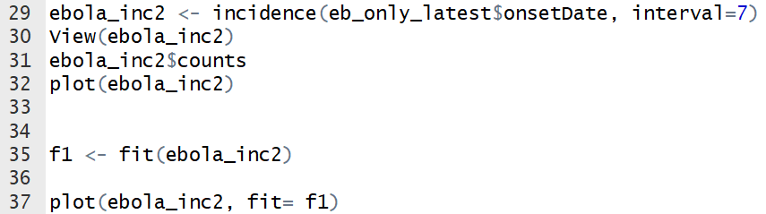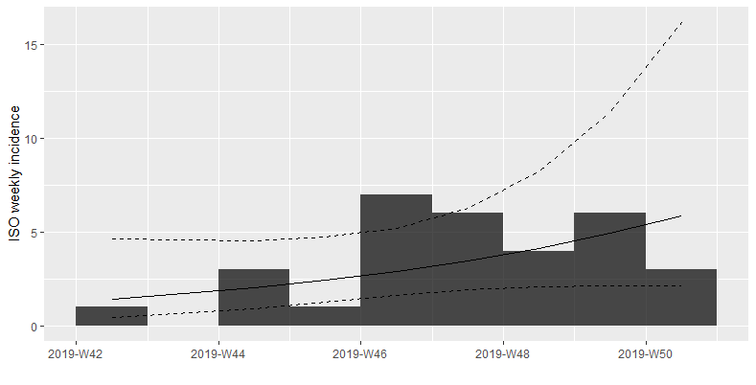

**Trying all splits in the 7 days incidence:**

> best.fit

$`df`

dates mean.R2

1 2019-11-04 -0.5166954

2 2019-11-11 0.2877753

3 2019-11-18 0.2618481

$split

[1] "2019-11-11"

$fit

<list of incidence_fit objects>

attr(x, 'locations'): list of vectors with the locations of each incidence_fit object

'before'

'after'

$model: regression of log-incidence over time

$info: list containing the following items:

$r (daily growth rate):

before after

0.05111330 -0.02420851

$r.conf (confidence interval):

2.5 % 97.5 %

before -0.13217618 0.23440278

after -0.06161133 0.01319431

$doubling (doubling time in days):

before

13.56099

$doubling.conf (confidence interval):

2.5 % 97.5 %

before 2.957077 -5.244116

$halving (halving time in days):

after

28.63238

$halving.conf (confidence interval):

2.5 % 97.5 %

after 11.25032 -52.5338

$pred: data.frame of incidence predictions (9 rows, 6 columns)

$plot

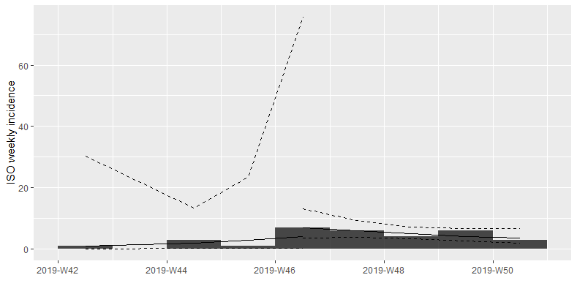

**The model for the split:**

> fit.both

<list of incidence_fit objects>

attr(x, 'locations'): list of vectors with the locations of each incidence_fit object

'before'

'after'

$model: regression of log-incidence over time

$info: list containing the following items:

$r (daily growth rate):

before after

0.05111330 -0.02420851

$r.conf (confidence interval):

2.5 % 97.5 %

before -0.13217618 0.23440278

after -0.06161133 0.01319431

$doubling (doubling time in days):

before

13.56099

$doubling.conf (confidence interval):

2.5 % 97.5 %

before 2.957077 -5.244116

$halving (halving time in days):

after

28.63238

$halving.conf (confidence interval):

2.5 % 97.5 %

after 11.25032 -52.5338

$pred: data.frame of incidence predictions (9 rows, 6 columns)

**The model for the split, with sex does not want to work. (too little data)**

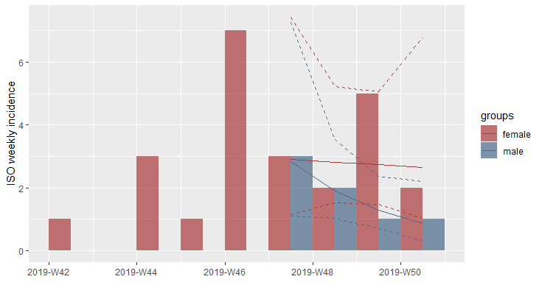

**Model without split, only working for part where we have both Males and Females. Seems to be decreasing for males whereas staying constant for Males.**